S0UTH EAST TECHNOLOGICAL UNIVERSITY

Clinic Appointment Management Ontology
CA2 Assignment Report

Module: Ontology and Semantic Web
Name: Leela Sasi Krishna Danda
Student Number: [W20115943]
Lecturer: Brenda O'Neill
Date: 16/04/2026

Table of Contents
Table of Figures 3
1. Introduction 4
2. Ontology Topic & Class Hierarchy 5
2.1 Class Hierarchy 5
3. Object Properties 6
4. Data Properties 7
5. Individuals 8
5.1 Patients 8
5.2 Doctors 8
5.3 Appointments 8
5.4 Prescriptions 8
6. Extension Tasks 10
6.1 Disjointness 10
6.2 Cardinality Restriction 10
7. Reasoning 12
7.1 Consistency Check 12
7.2 Inferred Relationships 12
8. SPARQL Queries & Results 13
8.1 Query 1 – List All Patients 13
8.2 Query 2 – Patient Names & Appointment Dates 13
8.3 Query 3 – Doctors & Departments 13
8.4 Query 4 – Appointments & Prescription Details 14
8.5 Query 5 – Cardinality Restriction Check 14
8.6 Query 6 – Patient Names & Medical Record Numbers 14
8.7 SPARQL Query Results Summary Table 15
9. Linked Data – GitHub Hosting 16
9.1 Uploading the Ontology 16
9.2 Public URL 16
9.3 How the Ontology Can Be Reused 16
10. Conclusion 17

Table Of contents

Figure 1– Class Hierarchy in Protégé 5
Figure 2– Object Properties 6
Figure 3– Data Properties 7
Figure 4– Individuals by Class 9
Figure 5– Disjointness Rules 10
Figure 6– Cardinality Restriction on Doctor 11
Figure 7– Reasoner Consistency Check (HermiT) 12
Figure 8– List All Patients 13
Figure 9–Patient Names & Appointment Dates 13
Figure 10: Doctors & Departments 14
Figure 11: Appointments & Prescriptions 14
Figure 12: Cardinality Restriction Check 14
Figure 13: Patient Names & Medical Record Numbers 15

Introduction

This document highlights information about the methodology used in creating an ontology within the management of appointments in the clinic. Ontology development was done in the Ontology and Semantic Web class.
Ontology is the domain knowledge area for the medical clinic, considering that it establishes the relationship between the patients, doctors, schedule, medicines, and departments. Ontology was created by using Protégé 5.x tool based on OWL 2 ontology language standard.
This report discusses the following stages as outlined in the assignment description:

- Class hierarchy design and subclass structure
- Object and data property definitions
- Individual creation and property assertions
- Extension tasks: disjointness and cardinality restrictions
- Consistency checking using the HermiT reasoner
- SPARQL querying for ontology validation
- Linked Data hosting via GitHub

Ontology Topic & Class Hierarchy

The selected ontology topic is Clinic Appointment Management System. It was found suitable for selection since the topic is applicable and represents different entities with varying relationships in a real-world situation to be modeled using OWL.

Class Hierarchy
The following classes were defined in the ontology:
    - Patient – represents individuals who visit the clinic for medical care
    - Doctor – represents medical professionals employed at the clinic
    - Appointment – represents a scheduled visit linking a patient to a doctor
    - Prescription – represents a medical prescription issued during an appointment
    - Department – represents a clinical department within the clinic (e.g., Cardiology, General Medicine)
The class Doctor is a sub-class of Person, while Patient is another sub-class of Person. This creates a common superclass for all humans. The hierarchy is similar to that found in the university ontology worksheet.
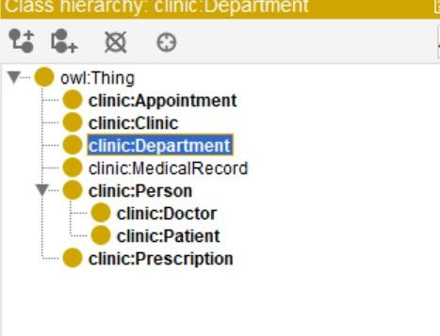
Figure 1– Class Hierarchy in Protégé

Object Properties

Object properties represent the connections between instances within the ontology. Below are some object properties that have been created with corresponding domains and ranges:
- hasAppointment - links a Patient to an Appointment (Domain: Patient, Range: Appointment)
- treatedBy - links a Patient to a Doctor (Domain: Patient, Range: Doctor)
- hasPrescription - links an Appointment to a Prescription (Domain: Appointment, Range: Prescription)
- worksIn - links a Doctor to a Department (Domain: Doctor, Range: Department)
- conductedBy - links an Appointment to a Doctor (Domain: Appointment, Range: Doctor)
These properties were entered as plain class names only in the domain and range fields in Protégé, consistent with correct OWL modelling practice.
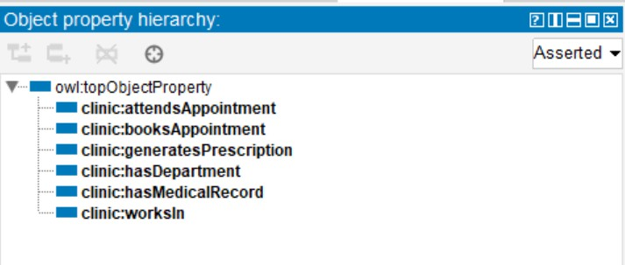
Figure 2– Object Properties

Data Properties

Data properties store literal values attached to individuals. The following data properties were defined:
- patientName – Domain: Patient, Range: xsd:string
- medicalRecordNumber – Domain: Patient, Range: xsd:string
- doctorName – Domain: Doctor, Range: xsd:string
- department – Domain: Department, Range: xsd:string
- appointmentDate – Domain: Appointment, Range: xsd:dateTime
- prescriptionDetails – Domain: Prescription, Range: xsd:string
Appropriate XSD datatypes were used for each property, ensuring type correctness within the ontology.
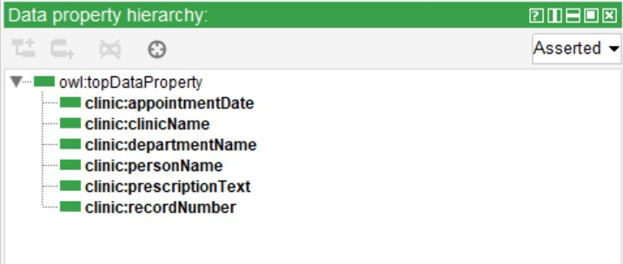
Figure 3– Data Properties

Individuals

Individuals were created in each class and filled with different values for their data properties and object properties. The following individuals have been created:

Patients
    - Patient_Priya – patientName: Priya Sharma, medicalRecordNumber: MR001
    - Patient_Rithvik – patientName: Rithvik Sharma, medicalRecordNumber: MR002

Doctors
    - Doctor_Arya – doctorName: Arya Mehta, worksIn: Department_GeneralMedicine
    - Doctor_Snigdha – doctorName: Snigdha Gopal, worksIn: Department_Cardiology

Appointments
    - Appointment_001 – appointmentDate: 2026-04-15T10:00:00, linked to Patient_Priya and Doctor_Arya
    - Appointment_002 – appointmentDate: 2026-04-16T11:30:00, linked to Patient_Rithvik and Doctor_Snigdha

Prescriptions
    - Prescription_001 – prescriptionDetails: Take one tablet daily for 5 days
    - Prescription_002 – prescriptionDetails: Apply ointment twice daily for 7 days

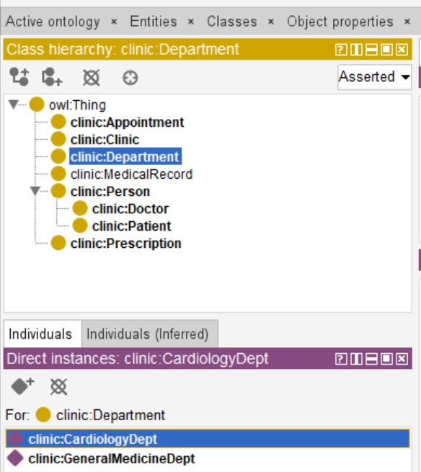
Figure 4– Individuals by Class

Extension Tasks

Disjointness
Disjointness axioms were added to ensure that individuals cannot belong to two incompatible classes simultaneously. This reflects real-world constraints, for example a Patient cannot also be a Doctor, and an Appointment cannot be a Prescription. The following disjointness rules were defined:
    - Patient disjoint with Doctor
    - Appointment disjoint with Prescription
    - Department disjoint with Person
These constraints prevent logical inconsistencies and allow the reasoner to detect any violations of these rules.
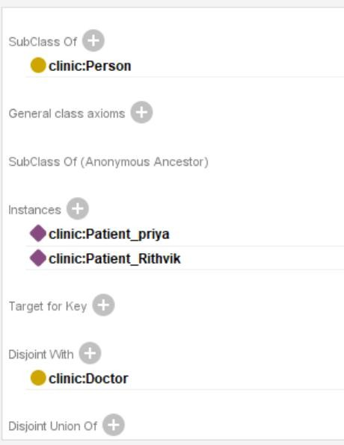
Figure 5– Disjointness Rules

Cardinality Restriction
A cardinality restriction was applied to the Doctor class to enforce the constraint that each Doctor works in exactly one Department. This is expressed in OWL as:
worksIn exactly 1 Department

This restriction was placed only on the Doctor class, ensuring no other classes are incorrectly constrained. It follows a business reality that every doctor has only one clinical department.
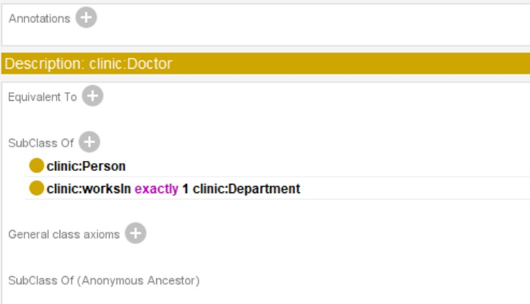
Figure 6– Cardinality Restriction on Doctor

Reasoning

After populating the ontology, the HermiT reasoner was executed using Protégé (Reasoner
→ HermiT → Start Reasoner) in order to determine whether there were any inconsistencies in the ontology, along with making any implicit connections.

Consistency Check
The reasoner completed without errors. Key indicators of a consistent ontology included:
    - No class names turned red in the class hierarchy panel
    - No unexpected individuals appeared under owl:Nothing
    - All disjointness rules were satisfied by the existing individuals
    - The cardinality restriction (worksIn exactly 1 Department) was satisfied for both Doctor individuals

Inferred Relationships
After running the reasoner, Protégé made inferences for the subclass relationships according to the property restrictions. The hierarchy was displayed under the Asserted/Inferred checkbox setting. There were no identified inconsistencies, thus the ontology is logically consistent.
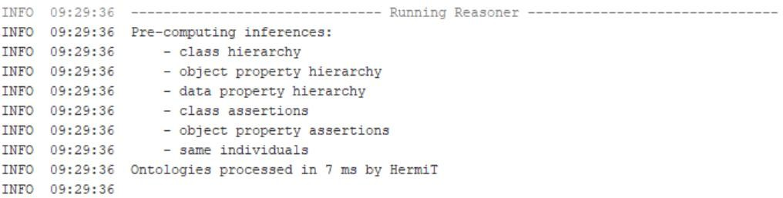
Figure 7– Reasoner Consistency Check (HermiT)

SPARQL Queries & Results

Six SPARQL queries were written and executed against the ontology using the Snap SPARQL Query tab in Protégé. All queries use the following prefix:
PREFIX clinic:
<http://www.semanticweb.org/ontologies/2026/clinic#>

Query 1 – List All Patients
This query retrieves all individuals that are members of the Patient class.
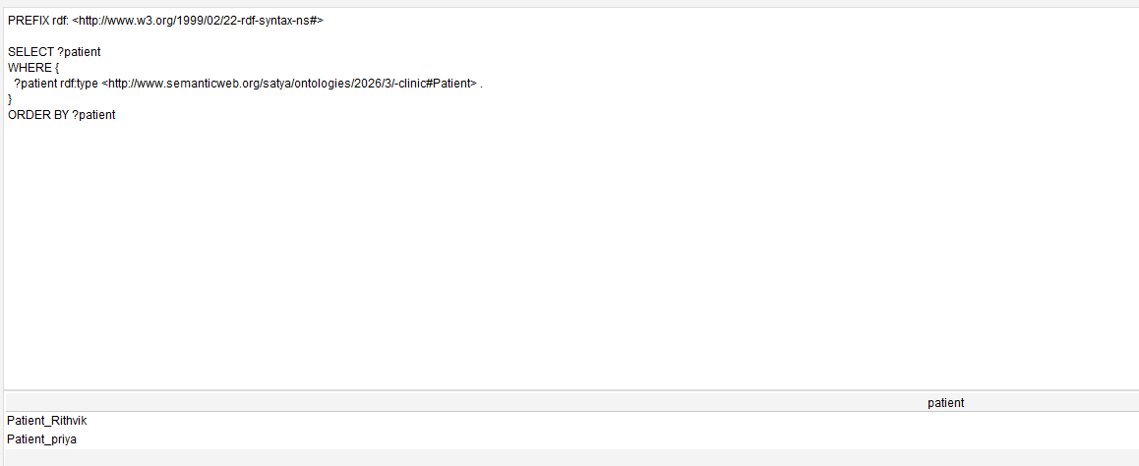
Figure 8– List All Patients

Query 2 – Patient Names & Appointment Dates
This query retrieves the name of each patient alongside the date of their associated appointment, traversing the hasAppointment object property and the appointmentDate data property.
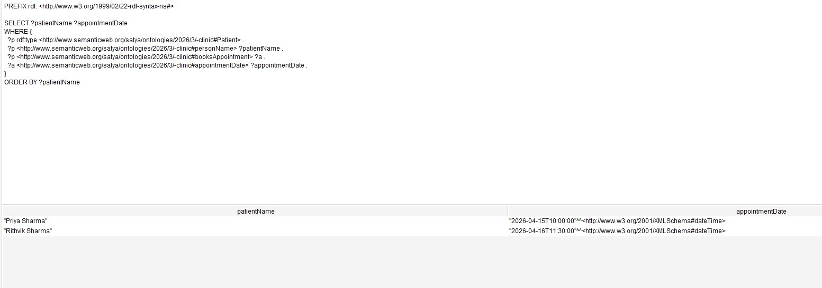
Figure 9–Patient Names & Appointment Dates

Query 3 – Doctors & Departments
This query fetches each doctor’s name and department through the use of worksIn and department properties respectively.

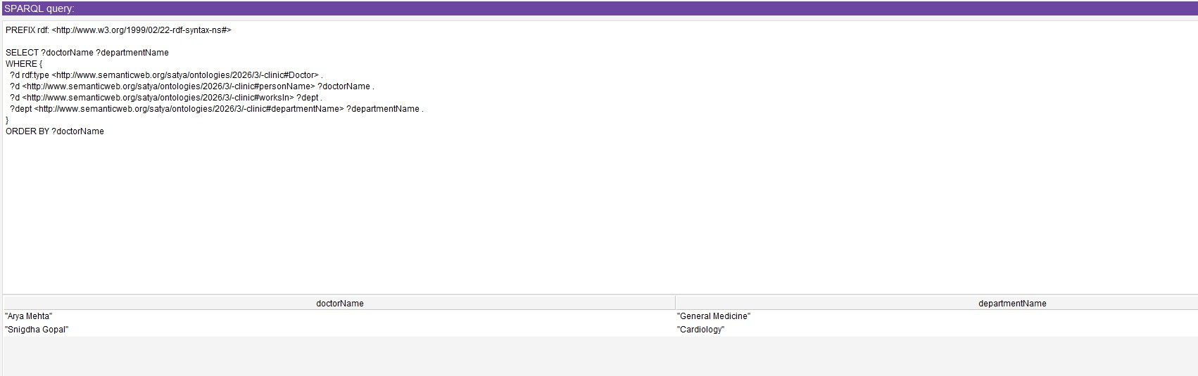
Figure 10: Doctors & Departments

Query 4 – Appointments & Prescription Details
This query combines Appointment and Prescription Classes using hasPrescription object property and gets appointment identifiers along with prescriptions’ descriptions.
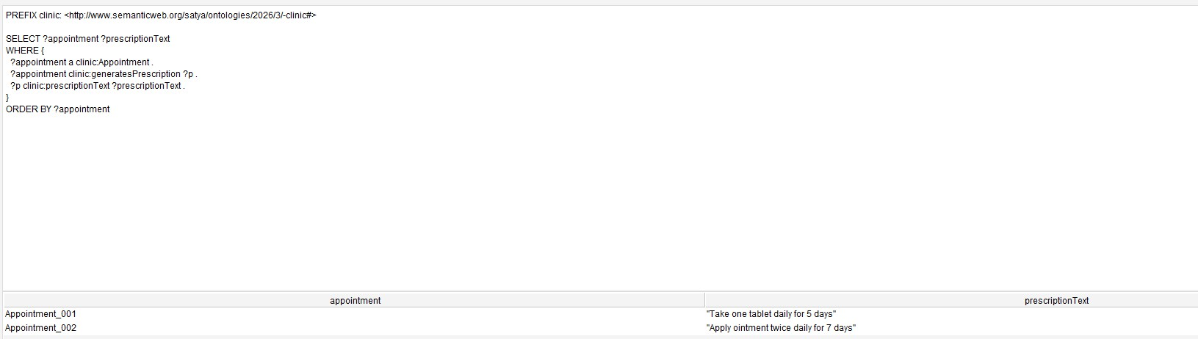
Figure 11: Appointments & Prescriptions

Query 5 – Cardinality Restriction Check
This query validates the cardinality restriction of a Doctor working only in one Department by counting the number of departments for each doctor.
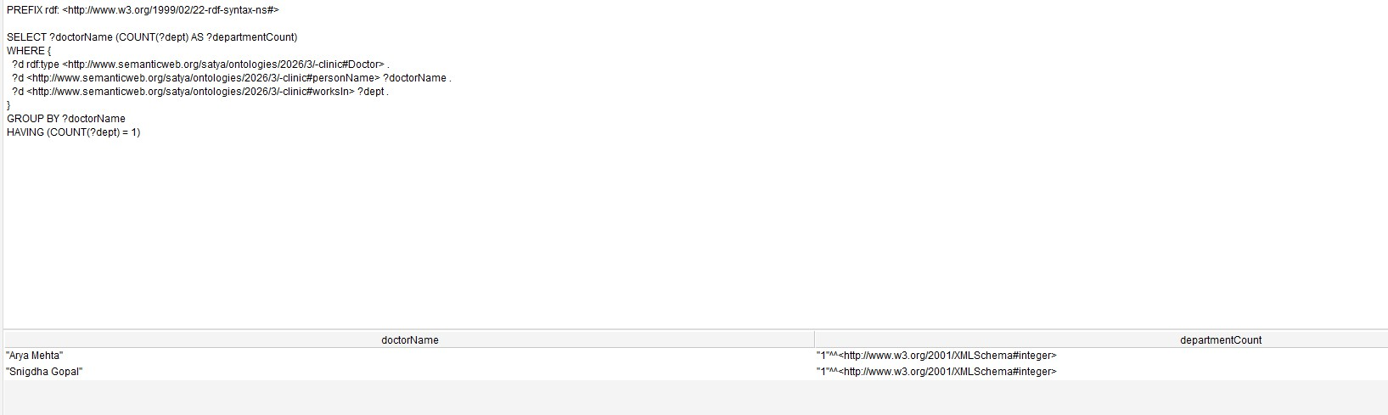
Figure 12: Cardinality Restriction Check

Query 6 – Patient Names & Medical Record Numbers
This query finds patient names together with their corresponding medical record numbers, which serves as an example of how to use the medicalRecordNumber data property.

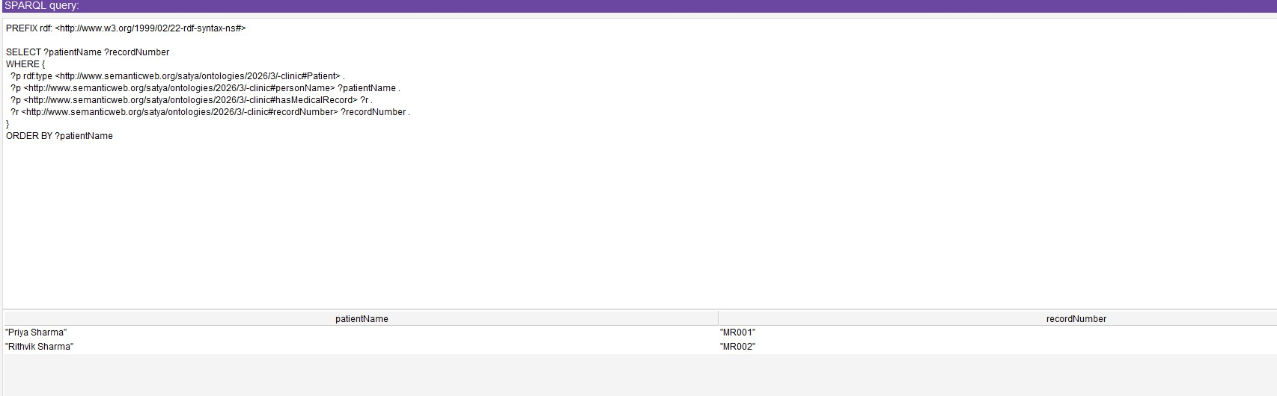
Figure 13: Patient Names & Medical Record Numbers

SPARQL Query Results Summary Table
The table below summarises all six SPARQL queries, their purpose, and the results returned:

Query No. | Description | SPARQL Focus | Output
1 | List all Patients | Class membership query | clinic:Patient_Priya, clinic:Patient_Rithvik
2 | Patient names & appointment dates | Data property retrieval | Priya Sharma – 2026-04-15T10:00:00,  Rithvik Sharma – 2026-04-16T11:30:00
3 | Doctor names & departments | Object property traversal | Arya Mehta – General Medicine, Snigdha Gopal – Cardiology
4 | Appointments & prescription details | Multi-class property join | Appointment_001: Take one tablet daily for 5 days; Appointment_002: Apply ointment twice daily for 7 days
5 | Doctor works in exactly one department | Cardinality restriction verification | Arya Mehta – 1, Snigdha Gopal – 1
6 | Patient names & medical record numbers | Data property retrieval – membershipID | Patient_Priya – MR001, Patient_Rithvik – MR002

Linked Data – GitHub Hosting

Uploading the Ontology
The completed ontology file (clinic_ontology.owl) was saved from Protégé in RDF/XML format and uploaded to a public GitHub repository. The steps followed were:
    - The ontology was saved in Protégé using File → Save As → RDF/XML format
    - A new public repository was created on GitHub
    - The .owl file was committed and pushed to the repository
    - GitHub Pages was enabled on the repository to make the file publicly accessible via a stable URL

Public URL
The ontology is publicly accessible at the following URL:

https://github.com/leelasasikrishnadandams-data/Clinic-Appointment-Management-Ontology

Conclusion

This assignment helped me demonstrate the entire process of ontology development in Protég. Using the selected domain, namely the management of clinic appointments, an OWL ontology was developed with all its components: classes with subclasses, properties for objects and data along with appropriate domains and range assignments, populated individuals, disjointness axioms, cardinality restrictions, reasoner verification, SPARQL querying, and Linked Data publication.
Using the HermiT reasoner to validate the ontology made sure that there was logical coherence within it, while executing the six SPARQL queries validated the fact that the data within it has been structured properly and is queryable. Uploading the ontology to GitHub shows how OWL files can be integrated into the larger Semantic Web ecosystem.

OntoGraf:

